**Lesson 3 Lesson-End Project**

**Create Blockchain Network**

|  |
| --- |
| **Project Agenda:** To create a Blockchain network  **Description:** You are a Blockchain expert for a Fintech company and have been asked to create a Blockchain network to demonstrate the working of Blockchain.  **Tools required:** Ubuntu and web browser  **Pre-requisites:** None  **Expected Deliverables:** Create blocks of an existing peer. Create another peer and a block for this new peer. Connect the newly created peer with the existing peer |

**Steps to be followed:**

1. Create blocks of an existing peer
2. Create another peer and a block for this new peer
3. Connect the newly created peer with the existing peer

**Step 1: Create blocks of an existing peer**

1. Open the browser in your lab and navigate to <https://blockchaindemo.io/>

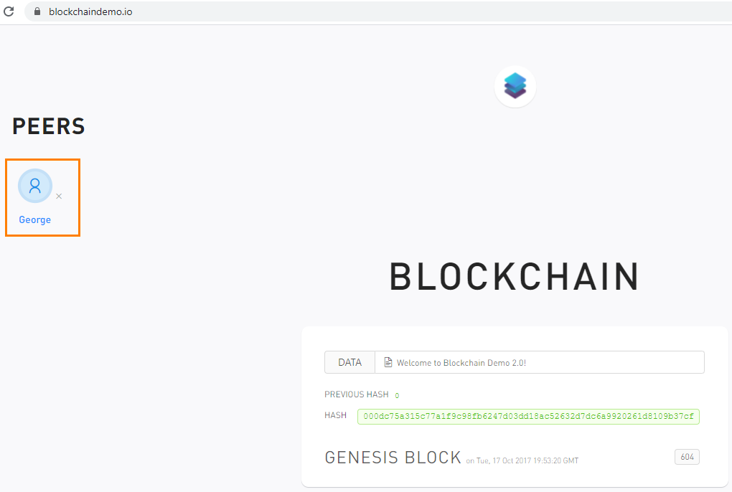

|  |
| --- |
| **Note:** Notice the existing peers under the **PEERS** sections. |

1. Enter some data in the **Data** field and click on **Add New Block**

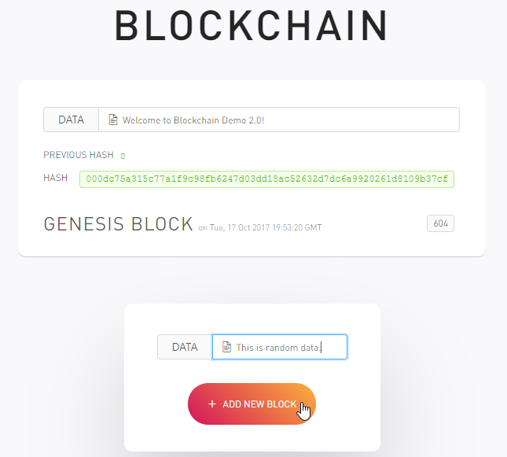

|  |
| --- |
| **Note:** Notice that it will create a new block just after the Genesis Block for the existing peer. |

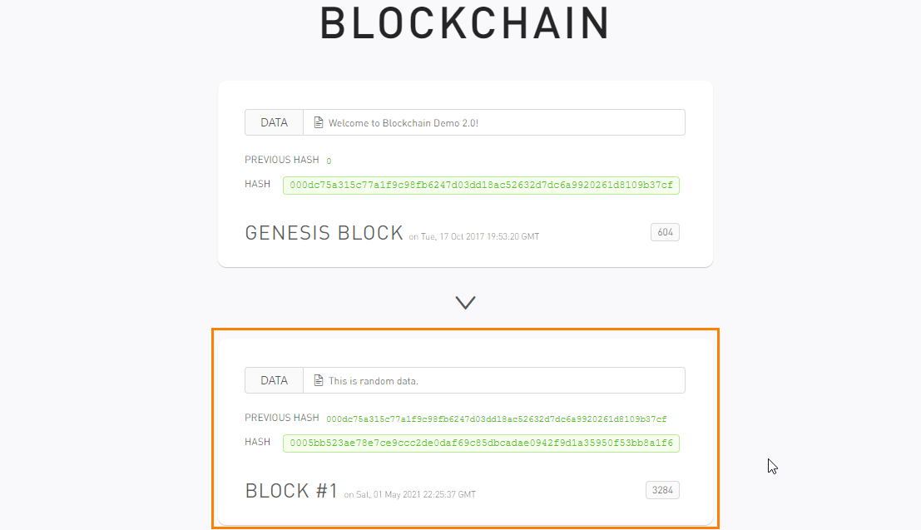

**Step 2: Create another peer and a block for this new peer**

1. Click on the **Add Peer** button to add a new peer

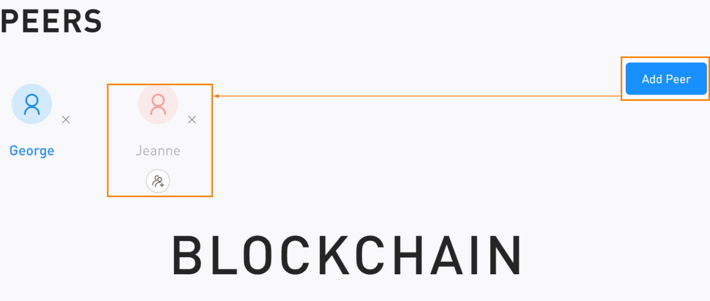

1. Click on the newly created peer to add a new block
2. Enter some data in the **Data** field and click on + **ADD NEW BLOCK** to add new blocks to this peer

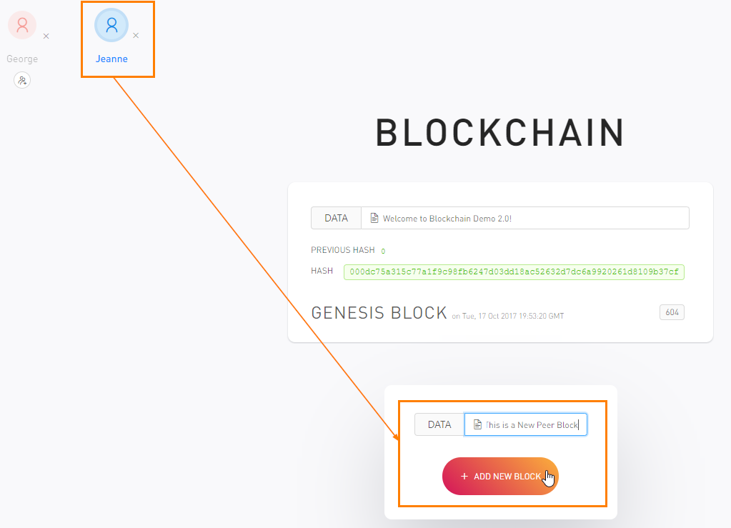

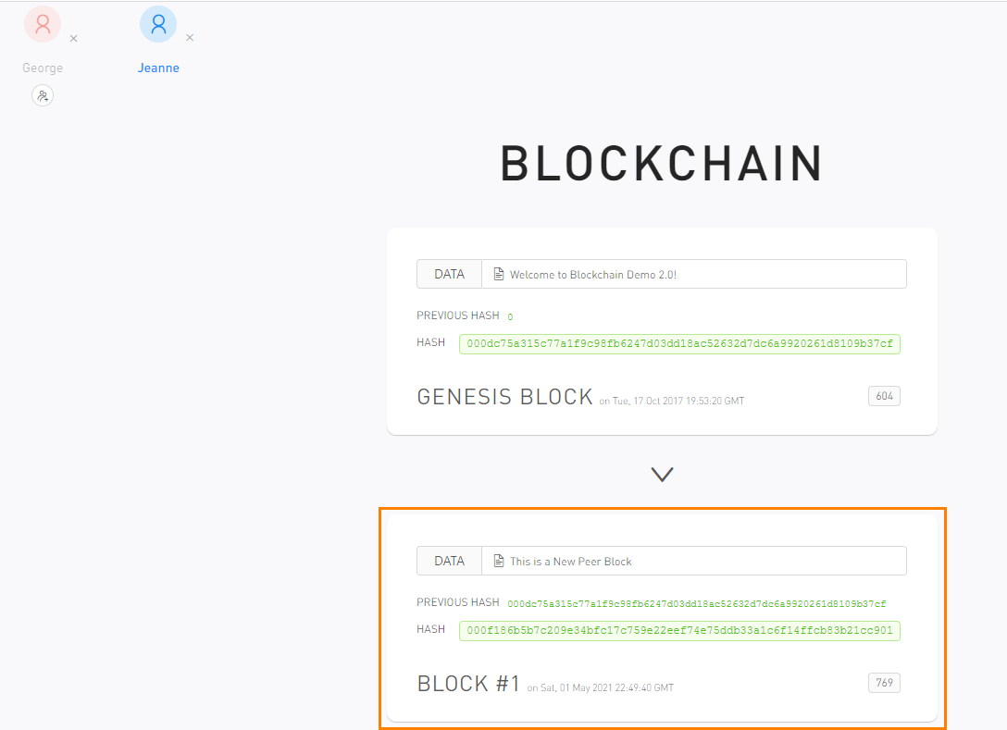

**Step 3: Connect the newly created peer with the existing peer**

1. Connect the newly created peer by clicking on the **Connect** symbol

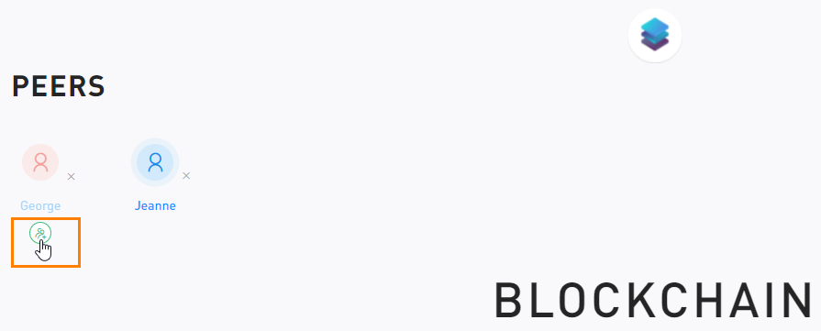

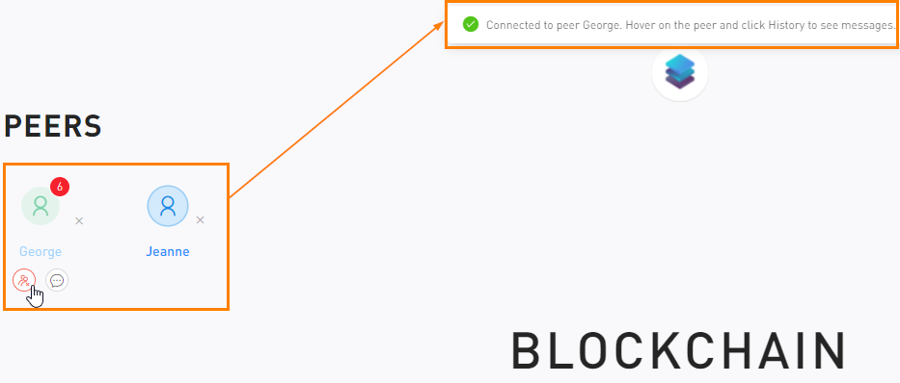

|  |
| --- |
| **Note:** Similarly, add more peers and blocks to create a Blockchain network. |